TASK 1 BASIC QUERYING
1.Select all columns for employees in the Marketing department
QUERY :
SELECT *
FROM employees
WHERE department='Marketing';
OUTPUT:
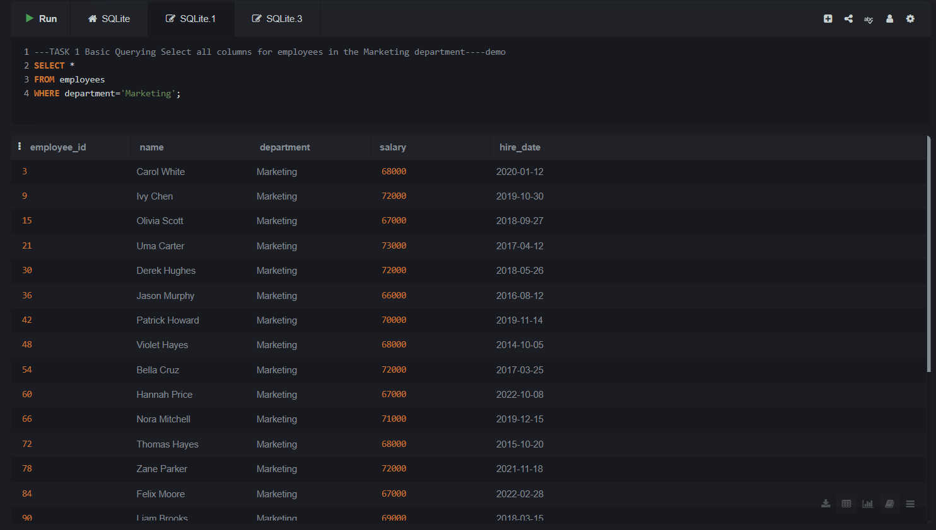

2. display only name, department for employees earning more than $90,000

QUERY:
SELECT name , department , salary
from employees
WHERE salary>90000;

OUTPUT:

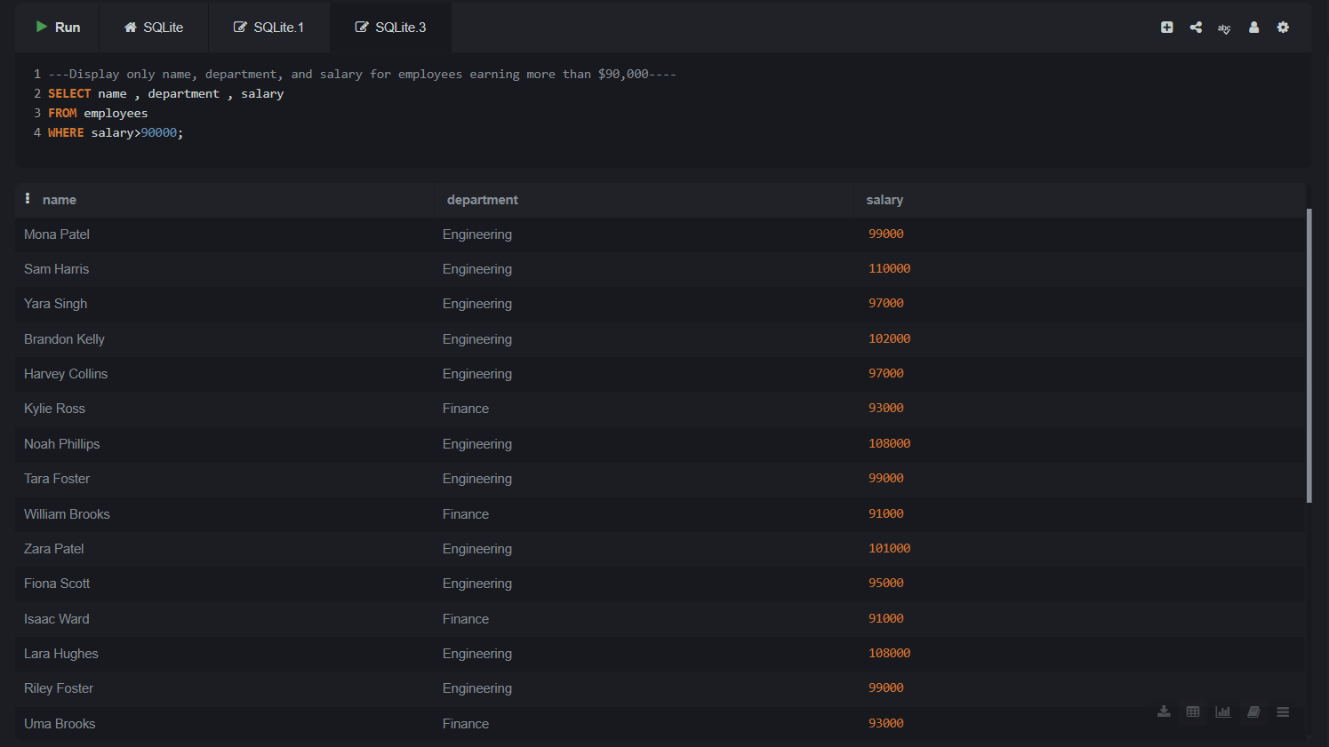

3. Find employees in either Sales or Finance departments
QUERY:
SELECT *
from employees
WHERE department='Sales' or department='Finance';
OUTPUT:
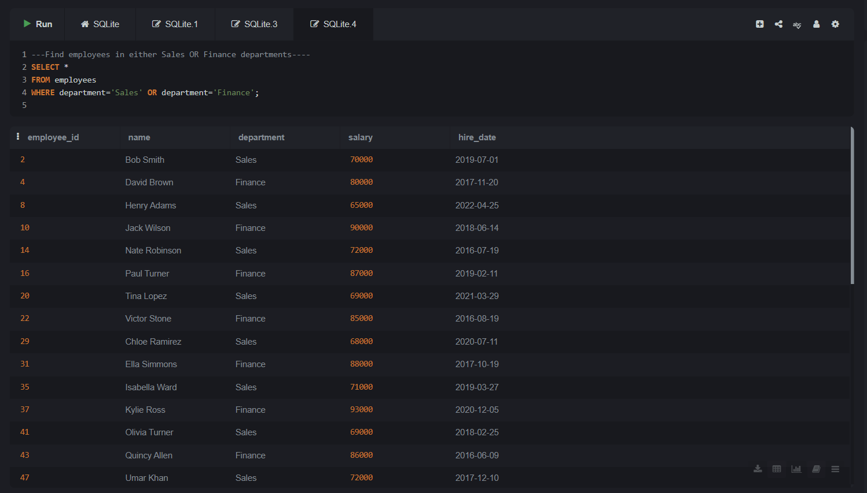

TASK 2:SORTING AND LISTING
1.The top 5 highest-paid employees (sort by salary descending , limit to 5)
QUERY :
SELECT *
FROM employees
ORDER BY salary DESC LIMIT 5;
OUTPUT:
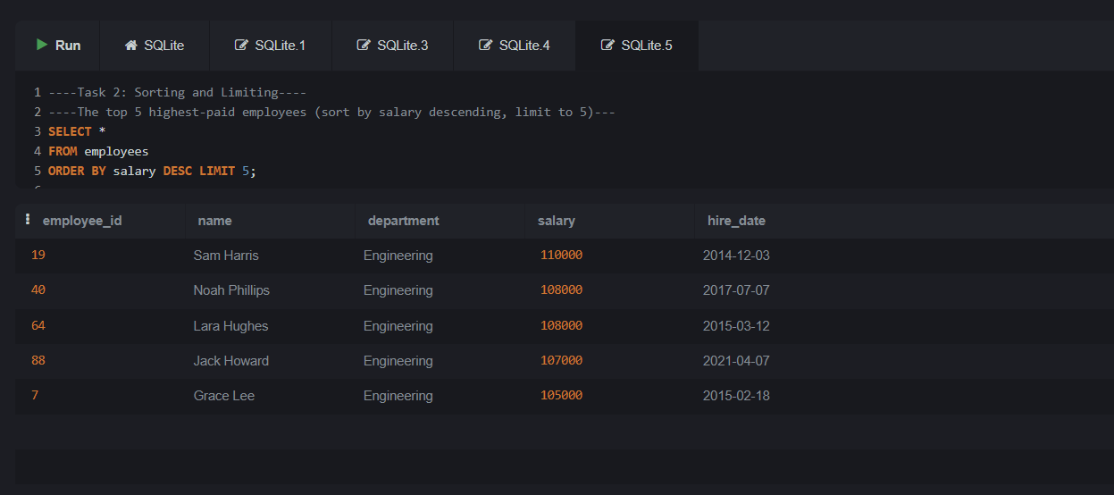

2.The 3 most recently hired employees in Engineering department (sort by hire_date descending)
QUERY:
SELECT *
from employees
WHERE department='Engineering'
ORDER by hire_date DESC LIMIT 3;
OUTPUT:
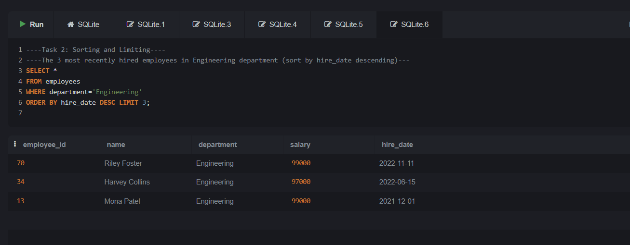

3.The oldest employee (by hire_date) who earns more than $75000 and is NOT in HR department
QUERY:
SELECT *
from employees
WHERE salary>70000 AND department!='HR'
ORDER BY hire_date ASC LIMIT 1;
OUTPUT:
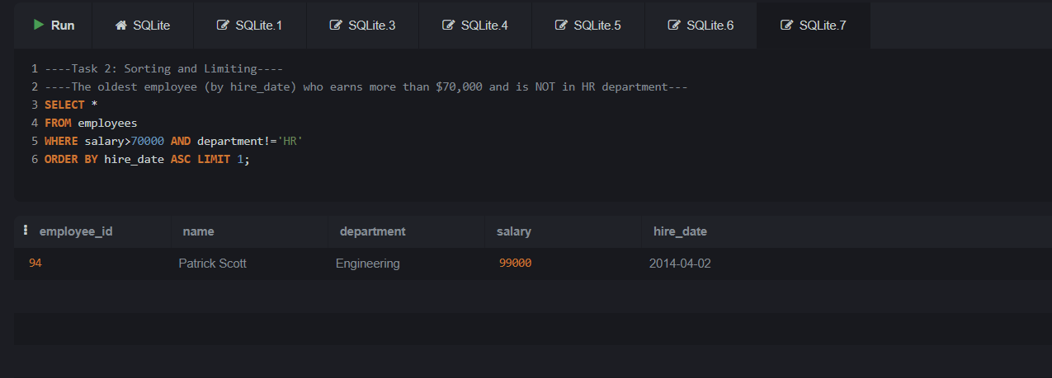

TASK 3 CALCULATED FIELDS AND ALIASES
- Calculate monthly salary for all employees :
  - Display name,salary, and salary/12 aliased as monthly_pay
  - Only show employees earning more than $60000
QUERY:
SELECT name,salary,salary/12 as monthly_pay
FROM employees
WHERE salary > 60000;
OUTPUT:
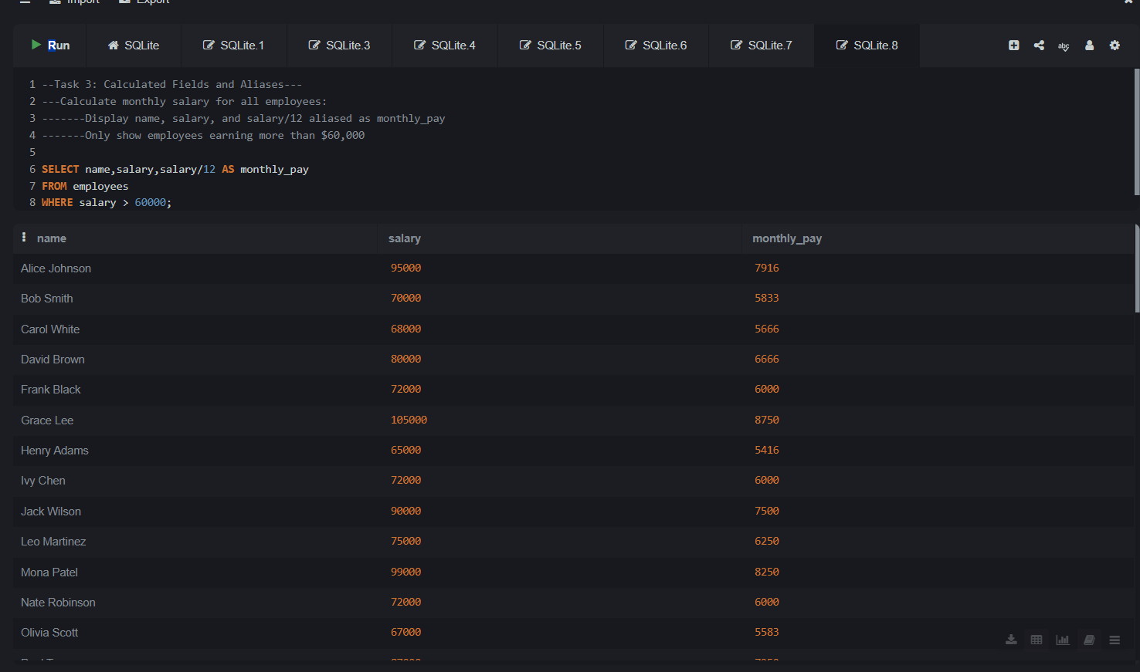

2.Create a report for the finance department showing
Name aliased as employee_name
Salary aliased as annual_salary
Salary/12 aliased as monthly_salary
Sort by salary descending

QUERY :
SELECT name as employee_name , salary as annual_salary , salary/12 as monthly_salary
FROM employees
WHERE department='Finance'
ORDER by salary DESC;
OUTPUT:
